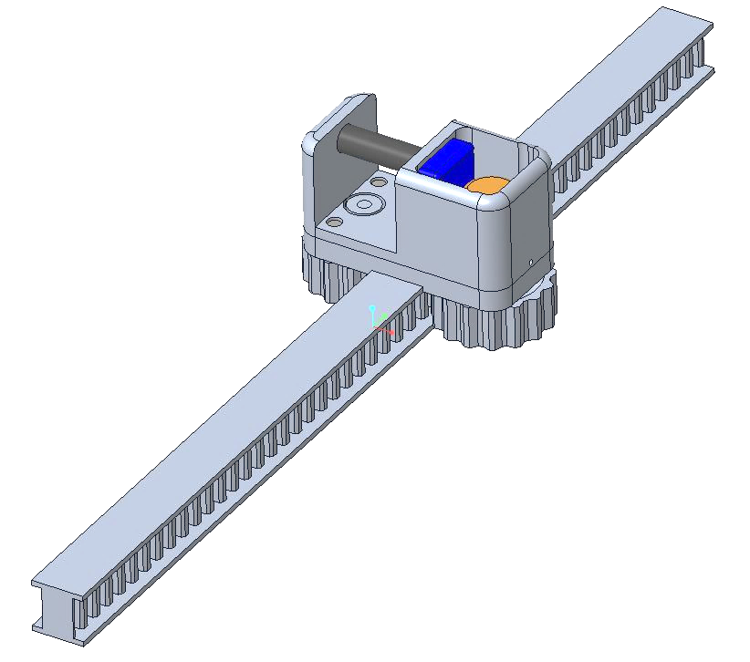

August 16, 2020

Connor Marshall

MIME: Matter In Motion Engineering (Not real)

Australia

Multi-USE Rail and Grip SYstem (MURAGS)

GrabCAD/NASA – Restraint and Mobility Aid System

# Introduction

The Multi-Use Rail And Grip System (MURAGS) has been developed as a solution to the challenge set by NASA and GrabCAD in the Restraint and Mobility Aid System Competition. The purpose of MURAGS is to provide a system which is unobtrusive, simple to maintain, versatile in all gravity environments and improves the mobility of personnel in space vessels.

The system uses a base rail which is freely mounted and can be easily extend. The rail provides restraint options in zero gravity environments as described in section 3.1 and is the attachment point for the grip system. This grip system can be operated in a variety of modes to offer powered mobility, mechanically assisted mobility or restraint anchoring as explained in section 3. As a first prototype, there are multiple avenues for improvement as outlined in section 4.

Throughout this report, measurements will be supplied under the metric system of units. This has no impact on the size constraints of the competition as the device is designed to fit any space and is scalable.

Overall, MURAGS is a simple and reliable solution with a wide variety of applications.

Contents

1. Introduction 1

2. System Overview and Components 2

2.1 Mechanical Setup and Ratcheting 4

2.2 Contact Points and User Experience 4

2.3 Electrical System 5

3. Implementation 5

3.1 Zero Gravity Usage 5

3.2 Low Gravity/Low Weight Usage 5

3.3 High Gravity/High Weight Usage 6

3.4 Summary of Implementation 6

4. Notes on Further Development 7

5. Conclusion 7

# System Overview and Components

MURAGS comprises of a rail and a grip system which together could replace ladders, elevators, anchor/tether points and heavy lifting apparatus. The CAD models produced for this concept design do not include details about the ratchet system or electronic components as these should be developed during further prototyping. Dimensions and space are provided for the components.

MURAGS operates as a track and gear system which can be locked in place or set to move a specific direction using a ratchet system. The electronic components will allow for powered mobility to aid heavy lifting or reduce user fatigue.

Table 1: Overview of the general properties of components in the system

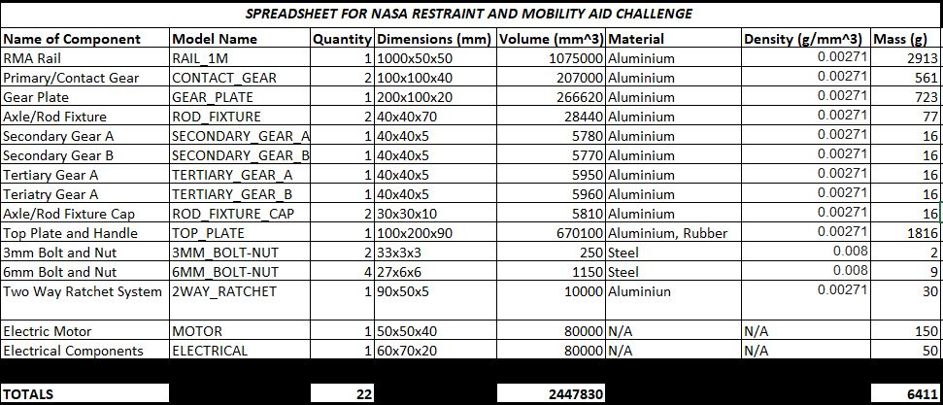

There are 21 parts that assemble to create the grip system and 1 part as the rail. Table 1 provides approximations for general properties of each of these parts. It is important to note that a number of these parts would be split into pieces such as the bolt/nut combinations and the two-way ratchet system. Discussing all components is unnecessarily detailed so only major components and key design choices will be discussed in this section. Figure 2 and 3 provide isometric and front views in both exploded and assembled mode as a reference for how the components interact. The CAD models will provide a more detailed visualisation of the system.

Please note that the CAD models were constructed in Creo PTC Parametric 6 and converted to STEP (.stp) files for viewing in Rhino 6 so exploded views and appearances may differ from those shown throughout the report.

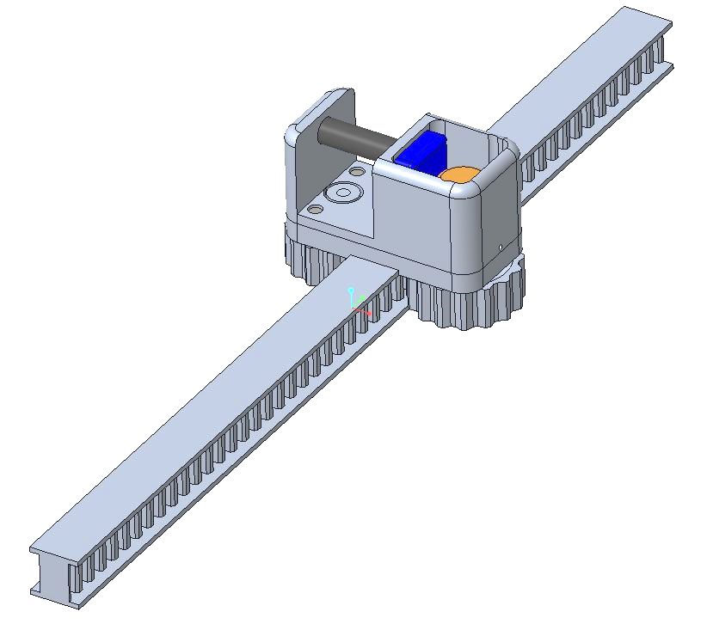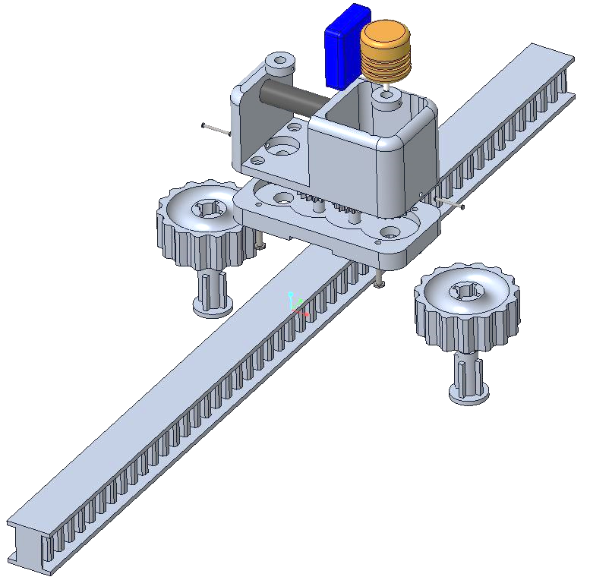

Figure 2: Isometric view of MURAGS in assembled and exploded views

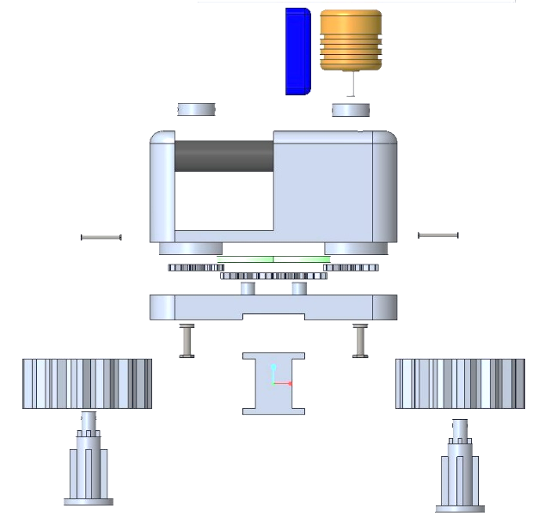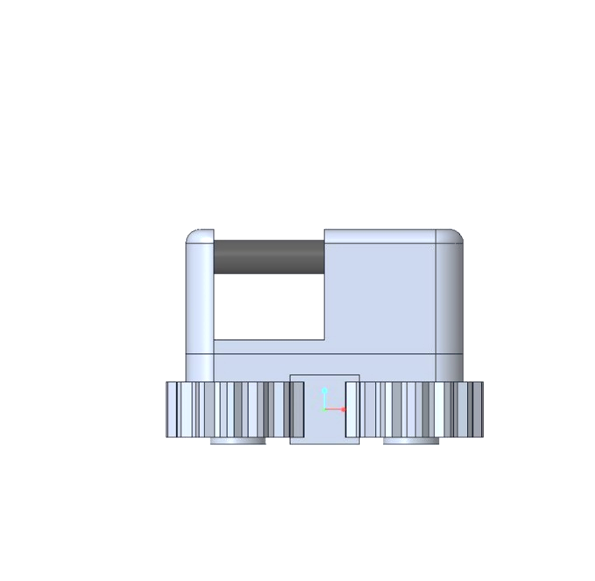

Handle

Electric Motor

Top Plate

Ratchet

S & T Gears

Electrical Components

Rail

Axle/Rod Fixture

Top Plate

Gear Plate

Primary Gear

Rail

Figure 3: Front view of MURAGS in assembled and exploded views with labels

## 2.1 Mechanical Setup and Ratcheting

The mechanical setup for MURAGS is quite simple. The rail provides teeth which interact with the primary gears. These gears are then locked to the axle/rod fixture with a secondary gear attached at the other end of the axle in a 1:1 ratio. To connect either side of the system, two tertiary gears a contained in the gear plate part with another 1:1 ratio. This entire 1:1 ratio is purely for conceptualisation. With optimization, this system may be altered but the overall purpose will remain the same, to transfer rotational motion to translation motion.

With only these components, MURAGS would operate as a simple sliding anchor point. To make the system more useful, a two-way controllable ratchet system is integrated inside the assembly. This ratchet system has not been modelled but the dimensions are displayed by the light green part. The system would match those of two-way ratcheting wrenches either use a cam and pinion setup or a more complex clutch setup. The details of this mechanism are not important in this conceptualisation phase.

With the ratchet system now integrated, the unmotorized version of MURAGS can operate as a sliding restraint anchor point which can be locked into place. Furthermore, with the ratchet set to move in only one direction, the user could slide MURAGS in the direction of travel and then pull themselves along. With two systems side by side, this would create a ladder like system without the space consumption of conventional rungs as explained in section 3.2.

Finally, with the addition of foot platforms and an electric motor, the system becomes an entirely independent system operating without energy input from the user. This means that the system could operate like an elevating platform for heavy objects if 4 sets were arranged as corners and the platform set on top. Alternatively, the electric system could be programmed to provide mechanical assistance to the user in high gravity situations. These uses will be elaborated in section 3.3.

## 2.2 Contact Points and User Experience

Arguably the most important aspect of any device is usability. In space especially, it is extremely important that systems are reliable and easy to maintain as well as simple to use and versatile.

On the first point, MURAGS assembles vertically with the gears first setting into the rails followed by the axles and layers of components on top. To lock everything into place, nuts and bolts are used to simplify assembly and disassembly. The use of simple mechanical systems also allows users to diagnose problems and fix the mechanism rather than requiring a replacement.

The top plate or user contact area of MURAGS is designed to be versatile. The wide, flat top and bottom faces provide easy footholds, the rubber coated handle provides an ergonomic grip and the simple box shape allows modification for other attachment devices. This ability for modification extends further into the rail itself. The 1 metre rail has a flat face on either end for simple extension and can be mounted directly to any flat surface or otherwise using simple offset mounts.

## 2.3 Electrical System

The electrical system was not designed for this project as it is a relatively simple task for an electrical engineer and does not have bearing on the overall concept. The system would operate the electric motor to generate lateral motion using the mechanical setup and allow for simple operation of the rachet device.

# Implementation

## 3.1 Zero Gravity Usage

In zero gravity environments, the system operates as a movable anchor or restraint in two ways. Firstly, the cut-out design of the rail means that clasps like carabiners and hooks can be attached to the system. This design allows the system to integrate with other existing RMA systems. An example of this use is during mealtime. Users can attach themselves to the rail using a carabiner which links to their belt/suit.

Alternatively, the large clearance handle means that ropes, cords or larger hooks can be easily attached. With the ability to slide the device, the anchor point can then also be moved. An example use for this device is during maintenance. The user can tether themselves to the device whilst working and then slide the device when they are moving to the next location. This improves safety by not having to untether and saves time when moving.

## 3.2 Low Gravity/Low Weight Usage

In low gravity environments (0G-0.6G), the systems ratcheting capability provides numerous applications. The first most obvious is that of a ladder. With two MURAGS side by side, the user can slide one grip along then use it to pull the other forward. An analogous example is rock climbing with the difference being that the grips slide rather than grabbing a new hold. The benefit of this design over a conventional ladder is the elimination of rungs. These rungs an be obtrusive in open hallways or prevent access of larger objects through a passage. Another application is as a platform or foothold. The flat top and bottom sides of the grip system can be used as platforms when trying to maintain a difficult position for extended lengths of time.

## 3.3 High Gravity/High Weight Usage

With the addition of the electric motor, MURAGS becomes an independent mobility system. In high gravity environments (0.6G+), the assisted mobility reduces fatigue of users and enables the lifting of very large objects.

For example, like the low gravity ladder, two devices can be placed side by side and used as foot platforms. Now motorized, the system can then act as an elevator for a single person. This concept can be extrapolated to create a heavy lifting system. With four MURAGS arranged in a square, a platform can be fixed to the flat sides of the devices. This platform could span an entire hallway and then be easily removed for free passage. With this setup, users could lift very heavy items or be transported in environments with greater gravity than on Earth. A render of this elevator system is shown in figure 4.

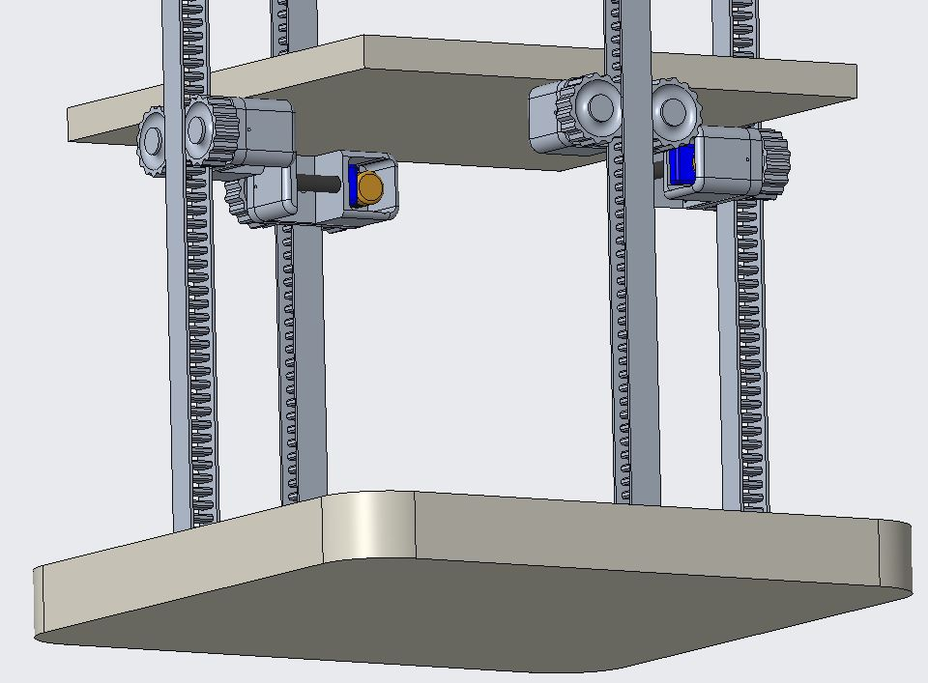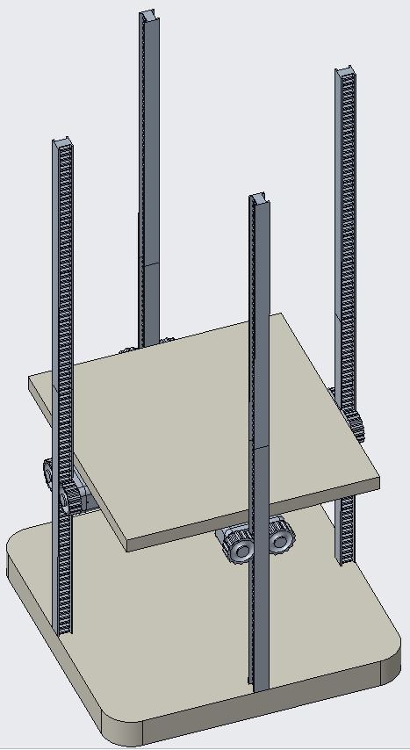

Figure 4: Rendering of the elevator concept comprising of four MURAGS, a base and a platform.

## 3.4 Summary of Implementation

In summary, the MURAGS system is highly versatile being applicable to environments beyond those specified (greater than Earth gravity). While many uses were outlined explicitly, it is important to note that MURAGS is designed to be modified and can be implemented in all RMA situations. Some areas of development will now be outlined.

# Notes on Further Development

Although MURAGS demonstrates a complete concept, several minor details can still be developed. These would not change the fundamental idea or purpose, but rather would expand the possible uses and optimize those that already exist.

The first point is to formally develop the electrical and ratcheting components. Each can be optimized and will enable a prototype to be produced. Software engineering would also enable automated or remotely controlled motion for the elevator applications in section 3.3.

To improve ergonomics, grippy materials could be added to each side of the top plate to improve traction when standing on it. Furthermore, other attachment methods could be integrated into the design. This would make it interface with other currently existing equipment.

Next, the platform mentioned in section 3.3 could be formally designed, although it would necessarily only be a square plate with bolt holes. This is a similar case with many other additional components and makes MURAGS adaptable on the fly.

Finally, aluminium and steel were the primary materials used in the design to ensure reliability and minimise weight. The device is still relatively heavy so material engineering would prove beneficial. The goal would be to create hard, durable materials which are also light for the mechanical components.

# Conclusion

In conclusion, MURAGS is designed to solve many RMA challenges with simple and versatile construction. It would replace static and dynamic anchor points, ladders and elevators, heavy lifting apparatus and operate in gravity environments ranging from 0G to upwards of 5G depending on application and failure analysis. MURAGS is an adaptable solution designed for the user and is suitable for use beyond the required criteria.